Week 1:

In this weekly task I made an HTML file in which I had made a simple page with a button which will give use the date and used some basic CSS and JS other than that also made to do list that had check boxes and when the checkbox is interacted it gets updated and the line-though the text appears which is made with the help of Java script and HTML.

Screenshot:

Week 2:

Task 1: Responsive web design is a way by which we can make website work on almost every device. It is important because websites are accessible on almost all small to big device, so we need to optimize our web pages according.

Task 2: Implementing responsive web design using CSS can be done by the syntax written below:

@Media only screen and (max-width: --px) {

}

Screenshot:

Task 3: Creating a user story and UI/UX design prototype is important while making a responsive website because using prototyping we can set the layout of our website and work on how different things would response and most importantly when we change bowsers width and height, we can see the changes and note it down which can be very helpful while working on a big project.

Screenshot:

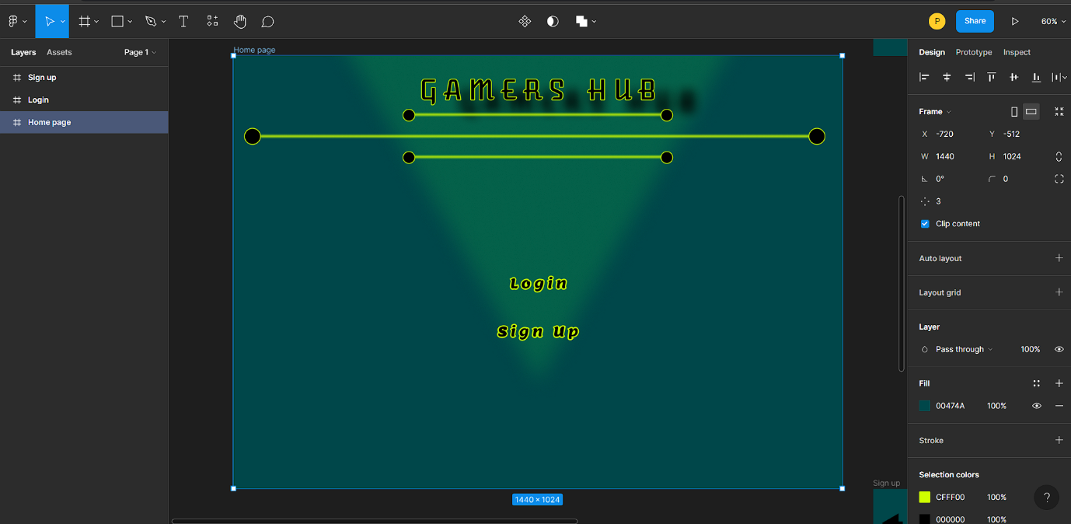

Task 4: Using utilities like canvas can be very helpful while making a responsive web app as we want to adjust the layout for different sizes at that time instead of working through each element, we can just do the change to the canvas and all the objects in the canvas will be updated.

Screenshot:

Week 3:

Task 1: In this task we defined string in java scripts that was outputted into the console also compared strings and changed the string from upper to lower case and vice a versa, everything done in java scripting. Also, I made a html file for connect the Java script and that way I would be able to access the console.

Screenshot:

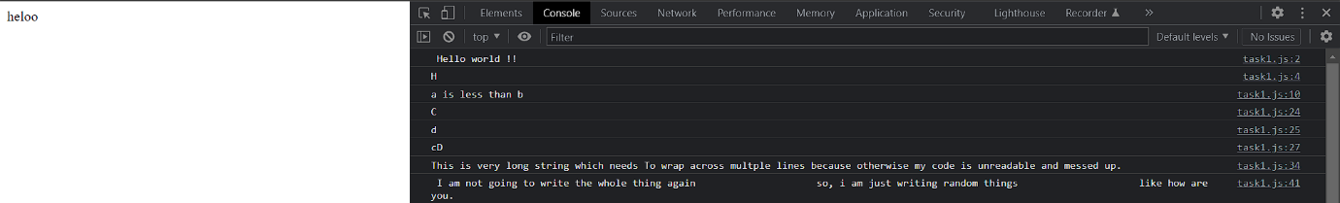

Task 2: In this task I created array in java script than printed the array in the console, added and remove elements from the array and learned slice, sort and foreach methods. Slice() method extracts a part of a string and returns the extracted string part. Sort() method sorts an array and the foreach() method calls the function of each element in an array.

Screenshot:

Task 3: In the last task using Date we printed Date and time in the console also changed the date and time and found the elapsed time between two times. Using different methods like Date, getday, getmonth and getfullyear.

Week 4:

Task 1: In the task one I added source Vue in the HTML code and made a script inside the same html page also made a button which after ever click increase the count value and prints it in the button. Also, I have added the hello world message in the script and then called I tin the body of the HTML.

Screenshot:

Task 2: In this task I modified the first task and removed the button and made an array in the script and using different conditional operators like v-for, v-if, v-else and v-show printed the assignments that were due tomorrow. v-for reads the list of details from an array ,v-if is having a if condition like if the give condition is true than run a specific code, v-else adds to the v-if , if the v-if statement is false than the v-else will be executed. Lastly v-show is the operator where a specific field is displayed irrespective of the conditions.

Screenshot:

Week 5:

Task 1: Components are the reusable Instances in the Vue JS, and this component can than be used as a custom element in the Vue instance.to define a new component we just type: Vue.component(‘name of the component’ {data and templates would be added here}).

Task 2: In an HTML form the user input needs to be stored for different uses on the website in such a condition the Vue has an extremely helpful field called the v-model which gets the inputted value of the user and then that can be used in java scripts and can be printed out.

Task 3: component registration is important before using a component we need to first register it so that the Vue can know what to do with this and where to do its implementation. To do a global registration of the component than we can do it by “app. component ()” if we want to do a local registration that it is done by typing “components.”

Task 4: props are used in the Vue components to pass the details from the parent component to the child of a component, it can be defined by just typing “props:”. Custom events are emitting and listening to events, to emit a custom event we can just type the “$emit” and then the name of the event. Slots makes the component easy reusable just like making a template which can than output with single line of code.

Week 6:

Task 1: In this task I have created a very simple html page which Is like a form where the user can input there name in the text box also can write password that is in dots but below the password box the output of what you have set the password is shown also, there is a range bar, number box where we can type or use the arrows to a specific number and a date selector.

Screenshot:

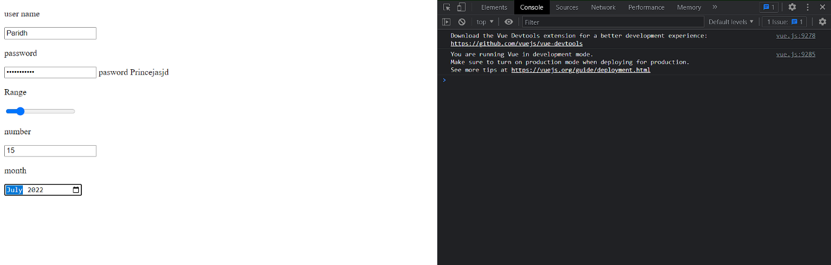

Task 2: In this task I have created multiple checkboxes whose values are changing when the checkbox is interacted in the first check box when it is not ticked the value would be false but after the check its value changes to true, the other checkboxes have a list of names which when selected is displayed at the bottom of the html.

Screenshot:

Task 3: In this task I have created an options bar where we get to select a single option from the drop-down list and then using Vue js made the selected value be printed next to the option bar.

Screenshot:

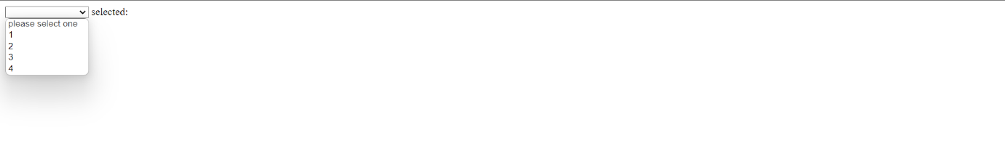

Week 7:

Task 1: In this task I have made a java script where I have declared some local components and then also added the global components. After that I created a simple Html page where all the components’ details can be printed out.

Screenshot:

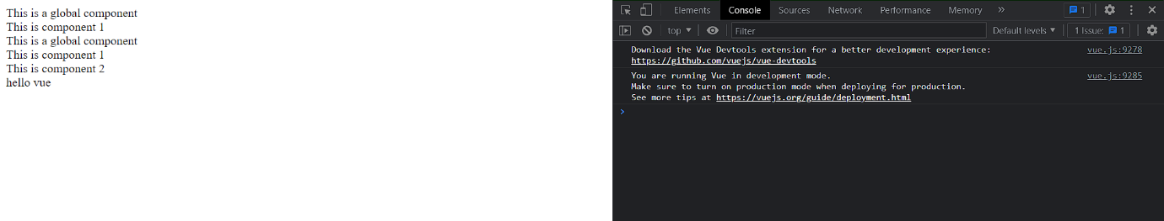

Task 2: In this task I have created a new html file in which using Vue I have done the scripting in that made component which than have props which passes the data from a parent component to a child component. Using this I have printed out different fruit names on the html page.

Screenshot:

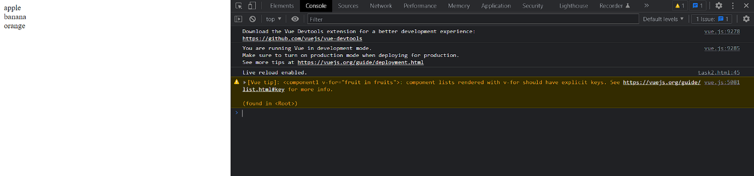

Task 3: In In the last task I have created a custom event in which every time the user press the random button a random number is picked by the code and then printed and when the user again clicks on the button the number is changed to a new random number.

Screenshot:

